February 22 – March 1, 2013
Weekly Update
- 2/27 Mid-Chapter 10 Test
- 3/1 Story 18 Test. Please see the Focus Wall below.
Helpful links:
http://www.mhschool.com/math/mathconnects/grade3/sg3c10lesson1.html
https://www-k6.thinkcentral.com/content/hsp/reading/journeys/na/gr3/ese_9780547360270_/volume2/launch.html#

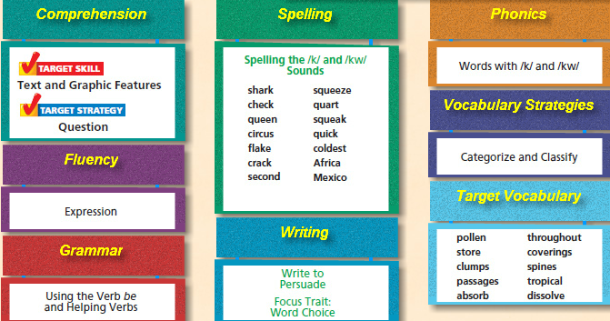
Homework
Spelling
- Write each word 3 times.
- Put each word in ABC order.
- Use each word in a sentence.
Vocabulary: Use each word in a well-crafted paragraph.
Math: Please complete daily worksheets.
Reading Log: Please read at least 20 minutes each night and complete the reading log on the other side of this page.

